**CIS 310 FINAL**

**Yamini Polcum**

47. **Price Table:**

CREATE TABLE PRICE (

PRICE_CODE NUMBER(2,0) PRIMARY KEY

PRICE_DESCRIPTION VARCHAR(20) NOT NULL,

PRICE_RENTFEE NUMBER(5.2) CHECK (PRICE_RENTFEE>= 0),

PRICE_DAILYLATEFEE NUMBER(5,2) CHECK (PRICE_DAILYLATEFEE>=0)

);

**Movie Table:**

CREATE TABLE MOVIE (

MOVIE_NUM NUMBER(8,0) PRIMARY KEY,

MOVIE_TITLE VARCHAR(75) NOT NULL,

MOVIE_YEAR NUMBER(4,0) CHECK (MOVIE_YEAR > 1900),

MOVIE_COST NUMBER(5,2),

MOVIE_GENRE VARCHAR(50),

PRICE_CODE NUMBER(2,0),

FORGEIN KEY(PRICE_CODE) REFERENCES PRICE(PRICE_CODE)

);

**Video Table:**

CREATE TABLE VIDEO (

VID_NUM NUMBER(8,0) PRIMARY KEY,

VID_INDATE DATE,

MOVIE_NUM  NUMBER(8,0),

FOREIGN KEY (MOVIE_NUM) REFERENCES MOVIE(MOVIE_NUM)

);

**Membership Table:**

CREATE TABLE MEMBERSHIP (

MEM_NUM NUMBER(8,0) PRIMARY KEY,

MEM_FNAME VARCHAR(30) NOT NULL,

MEM_LNAME VARCHAT(30) NOT NULL,

MEM_STREET VARCHAR(120),

MEM_CITY VARCHAR(50),

MEM_STATE CHAR(2),

MEM_ZIP CHAR(5),

MEM_BALANCE NUMBER (10,2)

);

**Rental Table:**

CREATE TABLE RENTAL (

RENT_NUM NUMBER(8,0),

RENT_DATE DATE,

MEM_NUM NUMBER(8,0),

FOREIGN KEY (MEM_NUM) REFERENCES MEMBERSHIP (MEM_NUM)

);

**Detail Rental Table:**

CREATE TABLE DETAILRENTAL (

RENT_NIUM NUMBER(8,0),

VID_NUM NUMBER(8,0),

DETAIL_FEE NUMBER(5,2),

DETAIL_DUEDATE DATE,

DETAIL_RETURNDATE DATE,

DETAIL_DAILYLATEFEE NUMBER (5,2),

CONSTRAINT DETAIL_RENT_VID_PK PRIMARY KEY (RENT_NUM, VID_NUM));

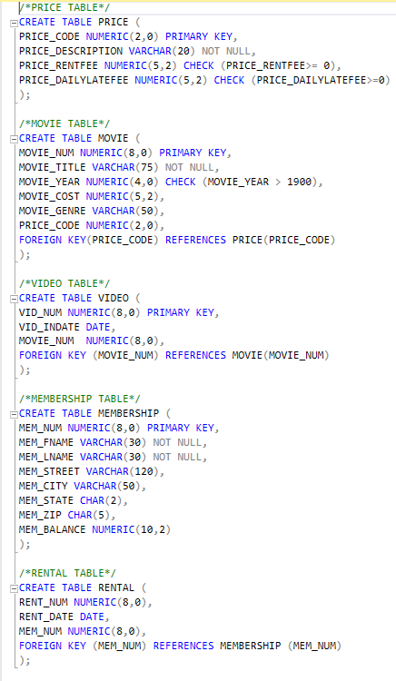

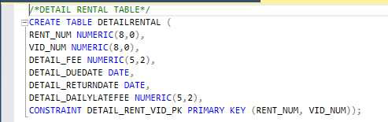

**PRICE TABLE**

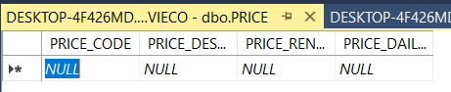

**MOVIE TABLE**

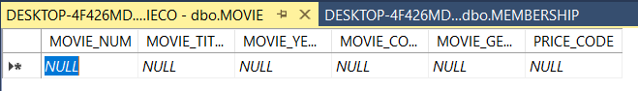

**VIDEO TABLE**

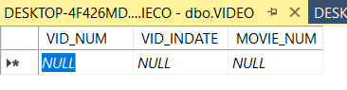

**MEMBERSHIP TABLE**



**RENTAL TABLE**

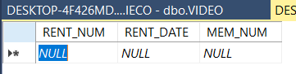

**DETAIL RENTAL TABLE**

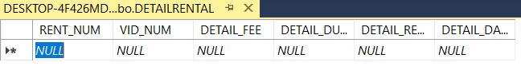

48. INSERT INTO PRICE VALUES (1, ‘Standard’, 2,1);

INSERT INTO PRICE VALUES (2, ‘New Release’, 3.5, 3);

INSERT INTO PRICE VALUES (3, ‘Discount’,1.5,1);

INSERT INTO PRICE VALUES (4, ‘Weekly Special’, 1, 0.5);

SELECT*FROM PRICE;

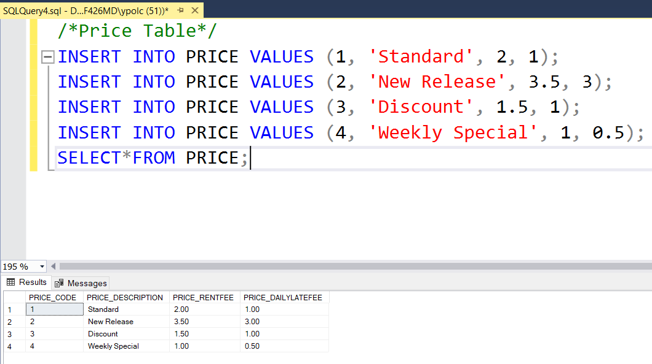

INSERT INTO MOVIE VALUES (1234, ‘The Cesar Family Christmas’, 2016, 39.95, ‘FAMILY’,2);

INSERT INTO MOVIE VALUES (1235, ‘Smokey Mountain Wildlife’, 2013, 59.95, ‘ACTION’, 1);

INSERT INTO MOVIE VALUES (1236, ‘Richard Goodhope’, 2017, 59.95, ‘DRAMA’, 2);

INSERT INTO MOVIE VALUES (1237, ‘Beatnik Fever’, 2016, 29.95, ‘COMEDY’, 2);

INSERT INTO MOVIE VALUES (1238, ‘Constant Companion’, 2017, 89.95, ‘DRAMA’, NULL);

INSERT INTO MOVIE VALUES (1239, ‘Where Hope Dies’, 2007, 25.49, ‘DRAMA’,3);

INSERT INTO MOVIE VALUES (1245, ‘Time to Burn’, 2014, 45.59, ‘ACTION, 1);

INSERT INTO MOVIE VALUES (1246, ‘What He Doesn’t Know’, 2015, 58.29,  ‘COMEDY’, 1);

SELECT*FROM MOVIE;

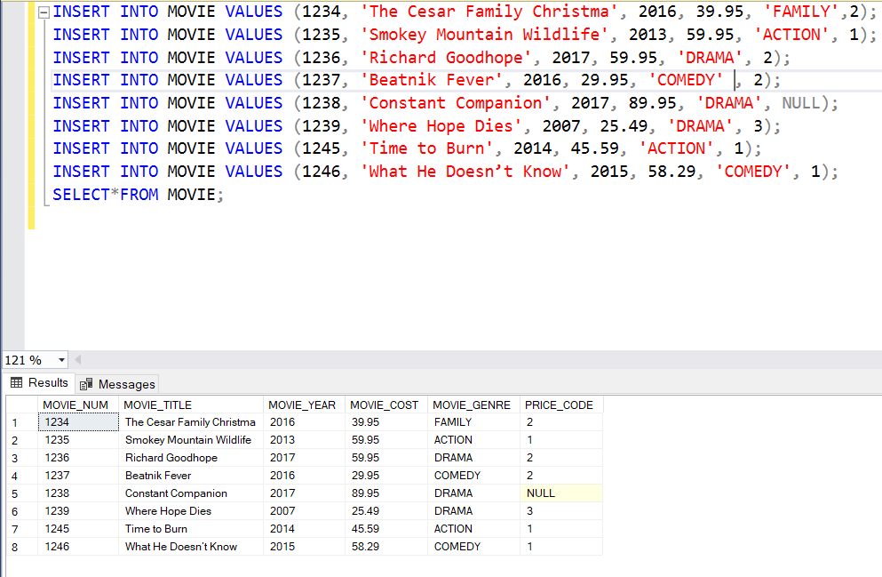

INSERT INTO VIDEO VALUES (54321, ’18-JUN-2017’, 1234);

INSERT INTO VIDEO VALUES (54324, ’18-JUN-2017’,1234);

INSERT INTO VIDEO VALUES (54325, ‘18-JUN-2017’,1234);

INSERT INTO VIDEO VALUES (34341, ’22-JAN-2016’, 1235);

INSERT INTO VIDEO VALUES (34342, ’22-JAN-2016’, 1235);

INSERT INTO VIDEO VALUES (34366, ’02-MAR-2018’, 1236);

INSERT INTO VIDEO VALUES (34367, ’02-MAR-2018’, 1236);

INSERT INTO VIDEO VALUES (34368, ’02-MAR-2018’, 1236);

INSERT INTO VIDEO VALUES (34369, ’02-MAR-2018’, 1236);

INSERT INTO VIDEO VALUES (44392, ’21-OCT-2017’, 1237);

INSERT INTO VIDEO VALUES (44397, ’21-OCT-2017’, 1237);

INSERT INTO VIDEO VALUES (59237, ’14-FEB-2018’, 1237);

INSERT INTO VIDEO VALUES (61388, ’25-JAN-2016’, 1239);

INSERT INTO VIDEO VALUES (61353, ’28-JAN-2015’, 1245);

INSERT INTO VIDEO VALUES (61354, ’28-JAN-2015’, 1245);

INSERT INTO VIDEO VALUES (61367, ’30-JUL-2017,’1246);

INSERT INTO VIDEO VALUES (61369,’30-Jul-2017,’1246);

SELECT*FROM VIDEO;

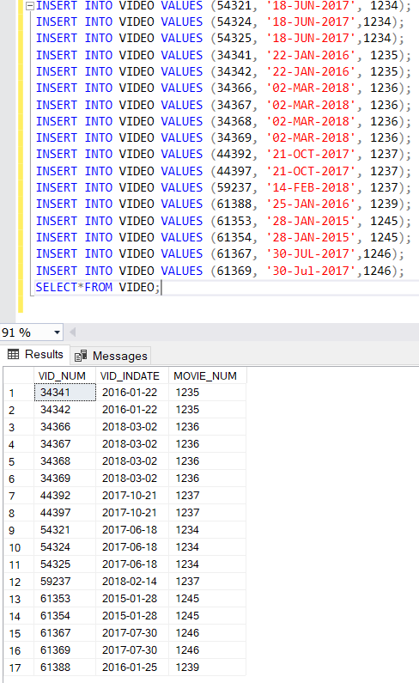

INSERT INTO MEMBERSHIP VALUES (102, ‘TAMI’, ‘DAWSON’, ‘2632 TAKLI CIRCLE’, ‘NORENE’,‘TN’, ‘37136’,11);

INSERT INTO MEMBERSHIP VALUES (103, ‘CURT’, ‘KNIGHT, ‘4025 CORNELL COURT’, ‘FLATGAP,’ ‘KY’, ‘41219’ ,6);

INSERT INTO MEMBERSHIP VALUES (104, ‘JAMAL’, ‘MELENDEZ, ‘788 EAST 145TH AVENUE, ‘QUEBECK,’ ‘TN’, 38579’ ,0);

INSERT INTO MEMBERSHIP VALUES (105, ‘IVA,’ ‘MCCLAIN, ‘6045 MUSKET BALL CIRCLE, ‘SUMMIT,’ ‘KY’, ‘42783’ ,15);

INSERT INTO MEMBERSHIP VALUES (106, ‘MIRANDA’, ‘PARKS’, ‘4469 MAXWELL PLACE’, ‘GERMANTOWN’,‘TN’, ‘38183’,15);

INSERT INTO MEMBERSHIP VALUES (107, ‘ROSARIO’, ‘ELLIOT’, ‘7578 DANNER AVENUE’, ‘COLUMBIA’,‘TN’, ‘38402’,5);

INSERT INTO MEMBERSHIP VALUES (108, ‘MATTIE’, ‘GUY’, 4390 EVERGREEN STREET’, ‘LILY’,‘KY’, ‘40740’,0);

INSERT INTO MEMBERSHIP VALUES (109, ‘CLINT’, ‘OCHOA’, ‘1711 ELM STREET’, ‘GREENVILLE’,‘TN’, ‘37745’,10);

INSERT INTO MEMBERSHIP VALUES (110, ‘LEWIS’, ‘ROSALES’, ‘4524 SOUTHWIND CIRCLE’, ‘COUNCE’,‘TN’, ‘38326’,0);

INSERT INTO MEMBERSHIP VALUES (111, ‘STACY’, ‘MANN’, ‘2789 EAST COOK AVENUE’, ‘MURFREESBORO’,‘TN’, ‘37132’,8);

INSERT INTO MEMBERSHIP VALUES (112, ‘LUIS’, TRUJILLO’, ‘7267 MELVIN AVENUE’, ‘HEISKELL’,‘TN’, ‘37754’,3);

INSERT INTO MEMBERSHIP VALUES (113, ‘MINNIE’, ‘GONZALES’, ‘6430 VASILI DRIVE’, ‘WINSTON’,‘TN’, ‘38076’,0);

SELECT*FROM MEMBERSHIP;

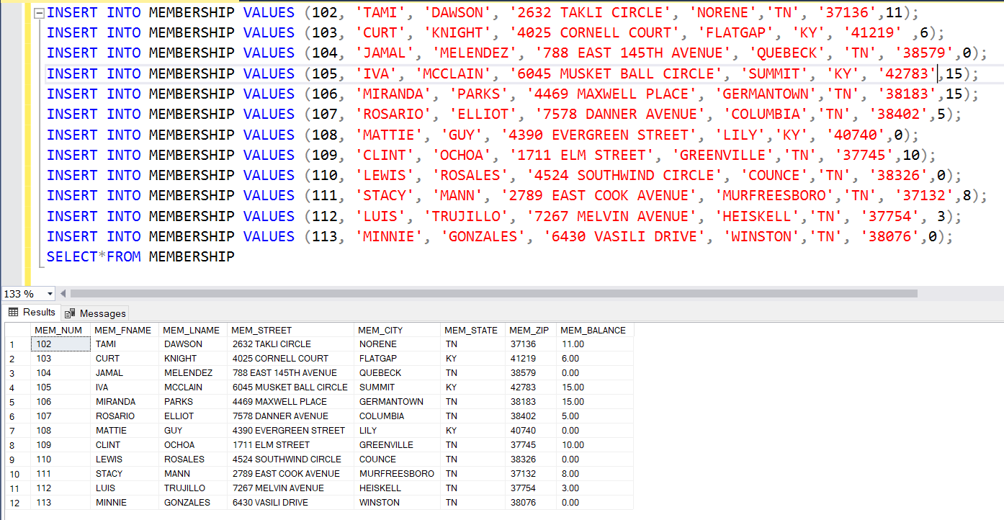

INSERT INTO RENTAL VALUES (1001, ’01-MAR-2018’, 103);

INSERT INTO RENTAL VALUES (1002, ’01-MAR-2018’, 105);

INSERT INTO RENTAL VALUES (1003, ’02-MAR-2018’, 102);

INSERT INTO RENTAL VALUES (1004, ’02-MAR-2018’, 110);

INSERT INTO RENTAL VALUES (1005, ’02-MAR-2018’, 111);

INSERT INTO RENTAL VALUES (1006, ’02-MAR-2018’, 107);

INSERT INTO RENTAL VALUES (1007, ’02-MAR-2018’, 104);

INSERT INTO RENTAL VALUES (1008, ’02-MAR-2018’, 105);

INSERT INTO RENTAL VALUES (1009, ’02-MAR-2018’, 111);

SELECT*FROM RENTAL;

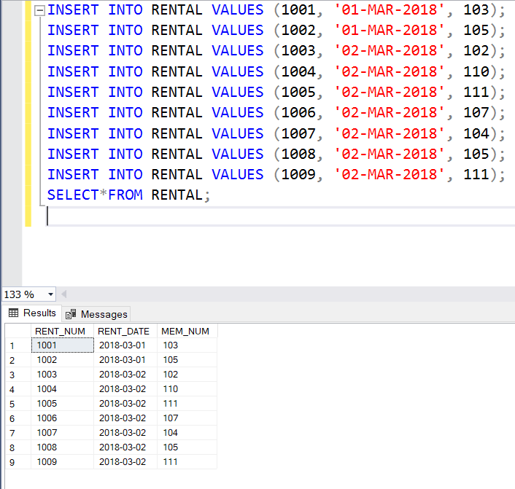

INSERT INTO DETAILRENTAL VALUES (1001, 34342, 2, ‘04-MAR-2018’, ‘02-MAR-2018’, NULL);

INSERT INTO DETAILRENTAL VALUES (1001, 34366, 3.5, ‘04-MAR-2018’, ‘02-MAR-2018’, 3);

INSERT INTO DETAILRENTAL VALUES (1001, 61353, 2, ‘01-MAR-2018’, ‘03-MAR-2018’, 1);

INSERT INTO DETAILRENTAL VALUES (1002, 59237, 3.5, ‘04-MAR-2018’, 04-MAR-2018’, 3);

INSERT INTO DETAILRENTAL VALUES (1003, 54325, 3.5, ‘04-MAR-2018’, 09-MAR-2018’, 3);

INSERT INTO DETAILRENTAL VALUES (1003, 61369, 2, ‘06-MAR-2018’, ‘09-MAR-2018’, 1);

INSERT INTO DETAILRENTAL VALUES (1003, 61388, 0, ‘06-MAR-2018’, ‘09-MAR-2018’, 1);

INSERT INTO DETAILRENTAL VALUES (1004, 34341, 2, ‘07-MAR-2018’, ‘07-MAR-2018’, 1);

INSERT INTO DETAILRENTAL VALUES (1004, 34367, 3.5, ‘05-MAR-2018’, ‘07-MAR-2018’, 3);

INSERT INTO DETAILRENTAL VALUES (1004, 44392, 3.5, ‘05-MAR-2018’, ‘07-MAR-2018’, 3);

INSERT INTO DETAILRENTAL VALUES (1005, 34342, 2, ‘07-MAR-2018’, ‘05-MAR-2018’, 1);

INSERT INTO DETAILRENTAL VALUES (1005, 44397, 3.5, ‘05-MAR-2018’, ‘05-MAR-2018’, 3);

INSERT INTO DETAILRENTAL VALUES (1006, 34366, 3.5, ‘05-MAR-2018’, ‘04-MAR-2018’, 3);

INSERT INTO DETAILRENTAL VALUES (1006, 61367, 2, ‘07-MAR-2018’, NULL, 1);

INSERT INTO DETAILRENTAL VALUES (1007, 34368, 3.5, ‘05-MAR-2018’, NULL, 3);

INSERT INTO DETAILRENTAL VALUES (1008, 34369, 3.5, ‘05-MAR-2018’, ‘05-MAR-2018’, 3);

INSERT INTO DETAILRENTAL VALUES (1009, 54324, 3.5, ‘05-MAR-2018’, NULL, 3);

SELECT*FROM DETAILRENTAL;

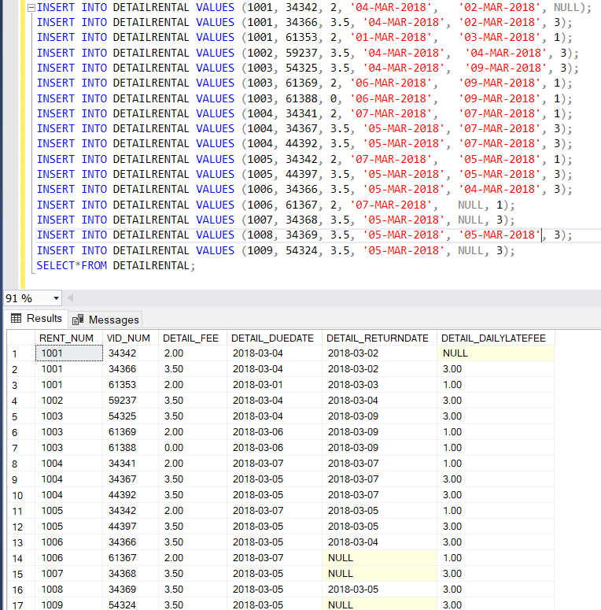

49. UPDATE MOVIE

SET MOVIE_YEAR = 2014

WHERE MOVIE_NUM = 1245;

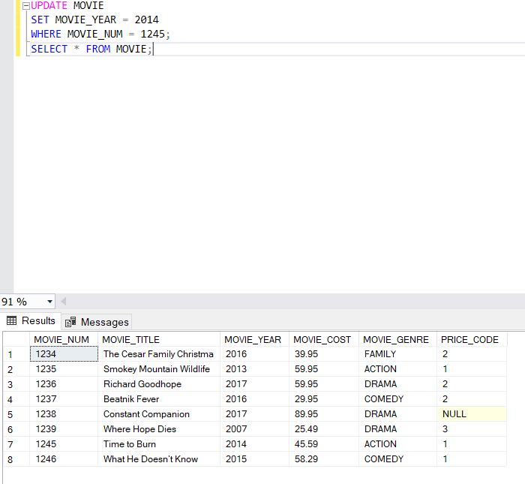



50. UPDATE MOVIE

      SET PRICE_CODE = 3

      WHERE MOVIE_GENRE = 'ACTION';

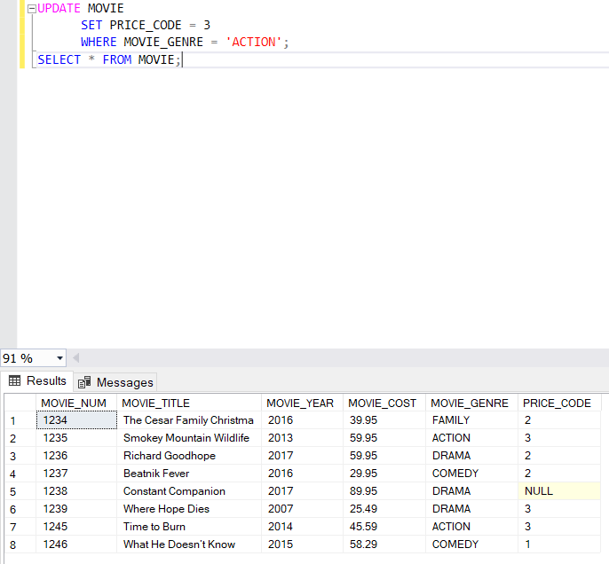



51. UPDATE PRICE

      SET PRICE_RENTFEE = PRICE_RENTFEE + 0.5;

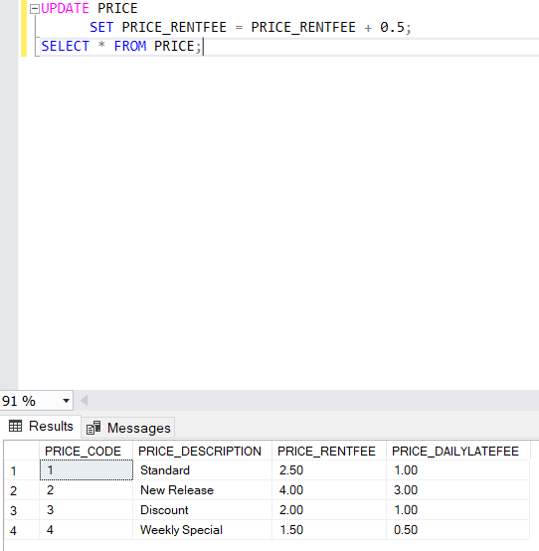



RELATIONAL DIAGRAM:

